SKIP WILKINS BIOGRAPHY (Long Version)
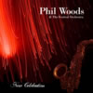
Skip Wilkins is an American jazz pianist who splits his time between Eastern Pennsylvania and Central Europe. While in the U.S. he makes his home in Delaware Water Gap, living at the famous jazz club Deer Head Inn. In his adopted hometown Skip is a regular presence in the club and at the annual COTA Festival of the Arts.
For many years, Skip has maintained an active international career as a pianist, composer, vocalist, workshop presenter, jazz choral director and college professor. He has many CD releases, including multiple international recordings, and has enjoyed performances with a host of international luminaries throughout his career. He performed often with Phil Woods, and is a featured soloist on Phil’s final big band release New Celebration. In fact, he and Phil were neighbors in the Gap. Wherever he has lived, he has performed and collaborated with top stars whenever they came to town – Phil Woods, David Liebman, Plas Johnson, Mark Murphy, Clark Terry, David Sánchez, Stanley Turrentine, Bobby Watson, Bob Dorough, Conte Candoli, Peter Erskine and Zuzana Lapčíková, among so many others.
Born and raised in eastern Massachusetts, Skip grew up in a musical home and began listening to jazz at a very early age. His father Bud played drums locally, so Skip was able to interact with professional musicians even as a small child. Like his Dad, he played drums too. Skip first found his way to the stage as a singer in kindergarten and has not left the stage since. In many ways his earliest experiences have proved the most enduring. He learned to love singing and listening to subtle harmonies before entering school, taking particular delight in the Great American Songbook repertoire of such composers as Richard Rodgers, George Gershwin and so many others, mainly from the first half of the twentieth century. Also drawn to the syncopation and polyrhythm in jazz recordings that he heard at home, it is readily apparent that the seeds of his future style were already planted in pre-school. Many years later, a seasoned professional pianist, Skip is noted for his lyricism, fascination with harmonic color, boundless rhythmic energy, and interest in exploring the vast canon of the Great American Songbook.
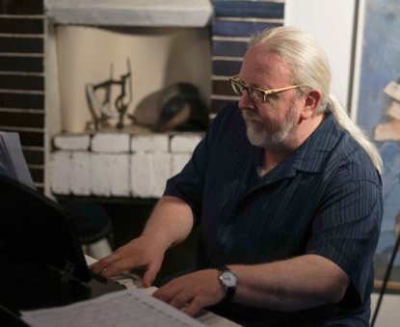
Skip has been touring in Central Europe frequently since 2007. He maintains a residence in Prague and performs throughout Europe in a variety of ensembles, with regular tours to the Czech Republic, Germany, Switzerland, Austria, Slovakia, Italy, Greece and France.
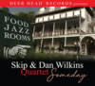
In 2019, Skip celebrates his 13th and 14th CDs as a leader or co-leader, with both releases featuring his son Daniel on tenor saxophone. In September 2019 Deer Head Records released Skip & Dan Wilkins Quartet: Someday. Skip and Dan selected an exquisite group of standards, many of which are not played often enough. The composers and lyricists – and the tunes themselves – are familiar, all part of the canon. The great bassist Tony Marino, long a member of David Liebman’s groups, makes his fifth CD recording with Skip on Someday. And for the first time, Skip records with his Deer Head neighbor, venerated drummer Bill Goodwin, for forty years a member of the Phil Woods Quartet and Quintet.
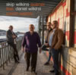
In January 2019, New Port Line Records released Czech Wishes, which Skip recorded in Prague with Dan and three stellar Czech musicians in the vanguard of the jazz scene in Prague – trumpeter Miroslav Hloucal, bassist Tomáš Baroš, and drummer Marek Urbánek. Skip composed all of the repertoire for Czech Wishes in Prague, completing most of it in three weeks, in between tours traversing Europe. “A well-conceived album, with heartfelt devotion to friends and family, far and wide, who have shaped Wilkins so profoundly” All About Jazz.
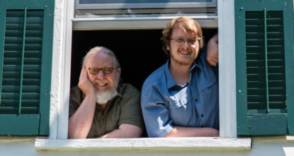
Skip and his son Dan have enjoyed numerous European tours together, as well as more frequent performances in and around Pennsylvania. About his musical relationship with his son, Skip writes: “It is a special delight to work on music with my son Dan. You could say that we both have old souls. We both love the canon – the Great American Songbook. We often exchange favorite old songs as well as favorite versions. I also love to write music for ensembles featuring Dan. In my career I have been fortunate to play and record with many great saxophonists both in the U.S. and in Europe, even including two NEA Jazz Masters. But for some music, you just have to grow your own saxophonist.”

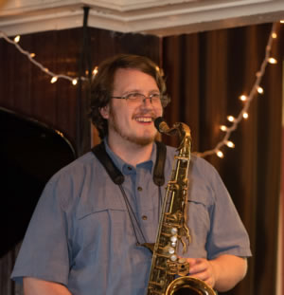
From 2012-2016, Skip’s main European working group was Trio WUH, a piano trio hailed as “arguably, one of the best new dynamic trios in the jazz world today” All About Jazz. Pianist Skip Wilkins, bassist František Uhlíř and drummer Jaromír Helešic gave 200 European concerts together – essentially whenever Skip could get to Europe. During those years of constant concertizing Skip was routinely referred to as the most active American pianist in the Czech Republic.
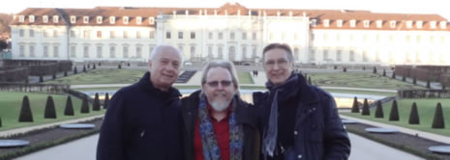
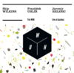
Together Trio WUH performed regularly in every corner of the Czech Republic, and throughout Germany, Austria and Switzerland. They also made their way to Italy, France and Slovakia. They headlined in a live 2013 performance on Czech National Television at a state event from Prague Castle, in the concert honoring retiring president Václav Klaus and his support for Jazz at the Castle. CD and DVD commemorations were released just months after the event. During the same tour, the group’s concert at the Festival Jazzinec in Trutnov was captured live. One year later, at Prague’s famous jazz club Reduta, their Trutnov performance was released on CD as Trio WUH: Live at Jazzinec.
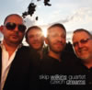
Earlier in 2013 Skip enjoyed his first New Port Line Records CD release Czech Dreams. Skip also wrote the music for this album in Prague for another superb group of Czech musicians – guitarist Libor Šmoldas, bassist Tomáš Baroš, and drummer Tomáš Hobzek. Saxophonist Rostislav Fraš and vocalist Maruška Puttnerová also made memorable guest appearances on the recording. "Truly spectacular – riveting – one of the most successful albums of the last year," music rating of ***** -Jazzport (Czech Republic)
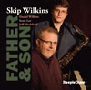
In 2012 SteepleChase LookOut released the CD Father & Son. Joining Skip and Dan were members of Skip’s New York Trio, bassist Scott Lee and drummer Jeff Hirshfield. Father & Son featured a new set of Skip’s compositions.
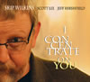 | 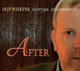
Just before Father & Son Skip recorded two trio CDs with Scott Lee and Jeff Hirshfield. Released on Dreambox Media in 2011: I Concentrate on You, a set of standards, including some well-known pieces and some less often played gems; and After, another set of new compositions by Skip, including some of the most varied writing he had issued to date.
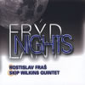
In August 2009, Skip recorded Frýdlant Nights with the Rostislav Fraš – Skip Wilkins Quintet. Released on CD in 2010 on the Czech Radio Prague label, the quintet features Wilkins with Americans Neil Wetzel (alto saxophone) and Gary Rissmiller (drums), along with Czech musicians Fraš (tenor saxophone) and Josef Fečo (bass). Wilkins’s compositions are featured prominently, ranging from edgy to lyrical. Together the group headlined at major festivals in Přerov and Vsetín and gave a live radio broadcast performance from Prague’s famous Jazz Dock, among many other performances. The Rostislav Fraš – Skip Wilkins Quintet continues to perform together in the Czech Republic, having celebrated their thirteenth annual tour together in Prague and Frýdlant in August 2019.
In addition to many dozens of performances with Trio WUH and Rost'a Fraš in every corner of the Czech Republic, some of Skip’s other noteworthy Czech performances include the Karel Velebný Summer Jazz Workshop in Frýdlant; as soloist with the Big Band Ceského Rozhlasu (Czech Radio) at the International Pražské Jaro (Prague Spring) Music Festival; Janáckův Maj festival in Ostrava; Brno Jazz Festival; Hello Jazz Weekend in Uherské Hradiště and Kyjov; Prague jazz clubs Agartha Jazz Centrum, Jazz Dock, U Malého Glena, Reduta and U Staré Paní; concert venues throughout the Czech Republic; and national broadcasts on Czech television and radio. Skip performs on and is interviewed prominently in two Czech Television documentaries filmed in Frýdlant. He is otherwise frequently interviewed on television and radio, and has given live performances on both Dobré Ráno and Živě on Czech National Television. In Germany, Skip headlines annually at Schlot in Berlin with German bassist Christoph Riggert.
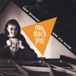
As he was coming up in Boston, he was fortunate to learn from and play with drummers Joe Hunt and Bob Moses and with saxophonists Jimmy Mosher and John LaPorta. In Denver, where he established his style, Skip was a well-known figure regionally, and often performed with marquee players when they visited the area. These included saxophonist Plas Johnson, vocalists Mark Murphy and Darmon Meader, trumpeter Conte Candoli, bassist Milt Hinton, and drummer Peter Erskine. He also made his first recording, Two Much Fun!, on Eaglear Records, as co-leader with flutist Jill Allen. While in the Rocky Mountain region, he toured the West with various groups and performed regularly at all the established jazz clubs, including the famous El Chapultepec in Denver. He also performed countless times at the University of Northern Colorado in Greeley, where he taught during his eight years in Colorado.
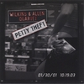
Relocated to eastern Pennsylvania in 1995, Skip resumed his performing career on the east coast with the Wilkins & Allen Quartet. In 2001, Cathexis Records released Petty Theft, which featured guest performances by Grammy-nominated saxophonist David Liebman. Skip also continued to perform in concert with all-stars, including saxophonists David Sánchez, Stanley Turrentine and Bobby Watson, trumpeter Clark Terry, trombonist Al Grey, drummer T.S. Monk, trumpeter Terell Stafford, vocalist Bob Dorough, and most recently NEA Jazz Master Phil Woods. He has performed with Philadelphia legends Mickey Roker, Larry McKenna, Joanna Pascale and John Swana, among many others.
Skip was offered the piano chair with the Phil Woods Big Band in 2012, which continues on as the Water Gap Jazz Orchestra, under the direction of Matt Vashlishan. The group gives monthly performances at the Deer Head and at other venues.
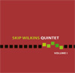 | 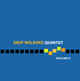
In 2005, Skip formed a new working ensemble, Skip Wilkins Quintet. Together they recorded three albums on Dreambox Media, each featuring his original compositions – Volume I, 2006; Volume II, 2007; and The Paint-Peeler, 2008. Group members included bassist Tony Marino and drummer Gary Rissmiller, guitarist Tom Kozic, and tenor saxophonist Paul Kendall.
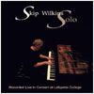
Also in August 2007, Dreambox Media released Skip Wilkins Solo – Live at Lafayette. The recording features some of Skip's compositions and also pieces by Thelonious Monk, Miles Davis, George Gershwin and Frederic Chopin. As ever, his playing ranges from lyrical to edgy, often turning unexpectedly. Skip’s music is heard worldwide on recording.
Skip maintains a regular presence at European jazz workshops, including the Karel Velebný Summer Jazz Workshop in Frýdlant, which began for him in 2007. From 2011-2014, he directed the Jazz Choral Ateliér at the Summer Choral Workshop of Lomnice, co-directing in 2012 & 2013 with his daughter Emily, a wonderful singer. In 2013 & 2014 Skip taught and performed at the International Jazz Workshop, Kryoneri, Greece. His son Dan joined him on the faculty there in 2013. Thus are both of Skip’s children part of the family business, like Skip’s Dad before them.
In 2011-2012, Skip made frequent trips to the Janáček Academy of Musical Arts in Brno during a Czech residency; his former students are active professionals working throughout the Czech Republic. During the same period, Skip directed the Skip Wilkins Singers, a twenty-voice Prague jazz choral ensemble that performed his arrangements and compositions. He continues to tour with Lomnice-based vocal sextet Bartet, a group that performs many of his arrangements.
In addition to his regular European concert presence, Skip has performed all over the United States. Some highlights include Bethlehem, PA's Musikfest; NYC’s Tavern on the Green; The Wichita Jazz Festival, where the Wilkins & Allen Quartet served as Artists-in-Residence; and The Blue Room at the Kansas City Jazz Museum. Skip also gave performances at the University of North Texas, Williams College, and the Rochester Institute of Technology, and at other venues in Arizona, Colorado, New York, Pennsylvania and North Carolina. Nearer to his home, Skip has performed often at East Stroudsburg University, Muhlenberg College, Moravian College and at Lafayette College. He is Associate Professor of Music at Lafayette.
Skip's recordings and performances have received regular critical acclaim. (See Reviews.) He is a past fellowship winner from the Pennsylvania Council on the Arts, for excellence in jazz composition. Many of the compositions for which he was recognized were included on Petty Theft.
Skip studied jazz composition and arranging with Herb Pomeroy at Berklee College of Music in Boston, and is a former faculty member at Berklee. He also studied and taught under Gene Aitken at the University of Northern Colorado. He counts bassist Jim Stinnett as one of his greatest mentors from his early years in Boston, and later, professors R. Evan Copley and Robert Ehle from the University of Northern Colorado.

